CS2401 Project 6 Spring 2021
Checkers!
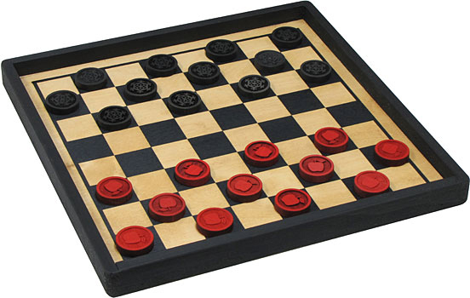
The final project for CS2401 will be a single large project which is to be submitted in three stages and therefore counts as three projects. For this project we will be implementing a game of CHECKERS, with the final product being a game that can play an intelligent game of CHECKERS against a human opponent, namely your instructor.
This game must be derived from the author's game class, and I have made a copy of this class available in ~jdolan/cs2401/projects/game. The files are game.h and game.cc. I have also included in this directory a file called colors.h which was created by a former student who has given us permission to use it. It allows you to adjust the colors of the screen during a text-based console or ssh session. I have altered the play function in the game class, by commenting out some of the code, so that it will work for the first phase of the project. By the end we will return to the original author’s game class with only a couple of little alterations.
The game class actually creates a map for us in how the project is developed, and at the end we will find that most of the ”AI” has already been written for us in this parent class. If you look at game.h, you will see that there are virtual functions that “must be overridden” and some that “may optionally be overridden.” Eventually you will write a child version for all the mandatory overrides, but you probably do not need to override any of the optional ones. (Although the winning function is an exception – his version doesn’t work.)
Most of you know the rules of this game, but here’s a quick review. Only the squares of one color are playable, and both players play on the same color. Basically each player’s turn consists of a diagonal move of their piece. You may not jump over your own pieces, but if you have an opponent’s piece is at next to your piece AND there is an empty space on the other side of that piece, you MUST jump that piece, and once you do so you have captured that piece. You may continue jumping with the same piece for as long as jumps are available, capturing pieces that belong to your opponent with each jump.
Normal pieces can only move in one direction, towards the opponent’s side of the board, but once you reach the back row of your opponent’s side your piece is “kinged” and may move in either direction. This is the only special privilege granted to kings. Play continues until one player can no longer make a move, typically when all of that player’s pieces have been captured. The player who cannot move loses the game and the other player wins. There is no tie possible.
The first stage is the design stage. In this part you decide how you will represent the pieces and how you will display the board. Good grades are given for the quality of the design, the attractiveness of the board, and the ease of the user interface. This first stage should be derived from the game class. You know that you will be creating a child class for Checkers, and that that class will have some way of storing the board. The board should be a two-dimensional array of spaces, pieces or pointers to spaces or pieces, where the spaces are another class which you have written. This board becomes the principle private member of the Checkers class. The spaces class should be able to store all the attributes that a space (or you can call it a piece) might have – emptiness, black, white, as well as mutators and accessor functions to transform a piece/space from one state to another.
You should then implement your design to the stage where I can see the board displayed and be allowed to make one initial move. The first step in doing this is to write your space/piece class, which will not be derived from anything, but has the ability to change states. Then, when you write your Checkers class, which will be derived from the author’s game class, the best first step, after declaring your board, is to create stubs for all of the author’s purely virtual functions. (A stub is a function with an empty implementation, which exists merely to validate a call, or to allow the program to compile.) For this stage you should implement the display_status, make_move, and an is_legal which returns true if the move is any of the four allowable initial moves. Notice that the author expects the move to be entered and passed around as a string, and you need to stay with this as it is an essential part of the design. Think of the string as merely a container for characters. (Remember you will have inherited the get_user_move function – just go ahead and use it.)
Blackboard submission of this 50 point stage (6a) is due at 11:59 p.m. on Thursday, April 15th.
In the second stage you implement a two-player game which allows two humans to play the game against each other on the computer. (Basically you will have one of the humans "be" the computer in the terms of the author's game class.) All rules should be enforced. This stage will involve much more extensive is_legal and make_move functions, since these now must embody all the rules of the game. You will also need an is_game_over and an overriding winning, but these are relatively easy
Blackboard submission of this 50 point stage (6b) is due at 11:59 p.m. on Friday, April 23rd.
In the final stage the computer will play an "intelligent" game against a human opponent. Again all rules should be enforced and the computer should not cheat. This is frequently called the "AI" stage of the game, and you will find that much of the AI work is done by the author's game class.
Electronic submission of this 50 point stage (6c) is due at 11:59 p.m. on Friday, April 30th, the sane day scheduled for out final exam. As explained in the syllabus this project is your final exam.
FOR EACH STAGE YOU WILL BEGIN WITH A DIFFERENT game.cc and samplemain.cc.

Pointers make this a lot harder, so I’m not recommending this for any but the most adventuresome.

